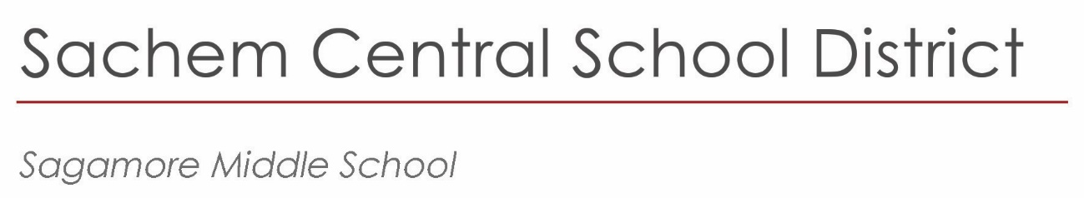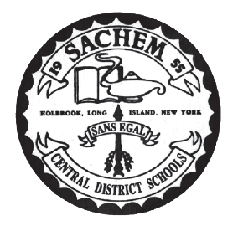

Sagamore is NOW participating in the program ***“Kids in Seats.”***

Kids in Seats works directly with schools throughout the United States to provide them with thousands of free tickets throughout the year to major sports and entertainment events. These can include tickets to major league NBA, NHL, MLB sports games, Broadway plays, star-studded concerts and much more. These memorable experiences serve as a valuable incentive in reinforcing positive achievements for our Sagamore students. We are not in control of what tickets are assigned to us.

**So How Does It Work?**

When Sagamore gets notified of free tickets, a message will go out to families to check your emails. If you are interested in attending the specified event, you must fill out a Google form attached to the email. You submit this form for your family’s chance to win. You will be entered into a lottery. Ticket winners will be chosen randomly and given to families. Any other costs for the event, such as parking fees or items inside the event, will be the responsibility of the family. We will only provide the actual ticket to be admitted to the event.

**Please login to your parent portal account and check that you have an up-to-date email and phone number on file.**

This is a great opportunity! We hope that this program can provide our Sagamore families with an entertaining and wonderful family night out – all for FREE!

Below is their website! Check it out if you want to learn more information about this wonderful organization!

<https://www.kidsinseats.org/>

|  |
| --- |
| 57 Division Street |
| Holtsville, NY  11742 |
| 631.696.8600 |
|  |
|  |

*Principal*   
Frank Panasci  
fpanasci@sachem.edu

*Assistant Principals*   
John Galligan, Ed.D

Donna Gregory

*Superintendent of Schools*

Christopher J. Pellettieri, Ed.D.

www.sachem.edu