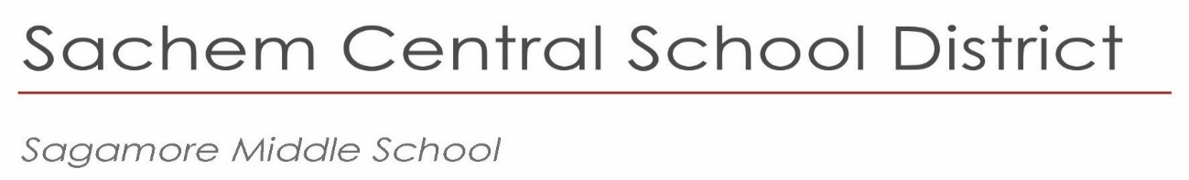

January 2024

Dear Parents and Guardians:

The Sagamore Guidance Department will begin the process of programming your child for seventh grade. To better prepare you and your child, there are several dates you need to be aware of.

**The week of January 15th,** all 6th graders will attend a meeting during their Social Studies classes to discuss information related to the 7th grade schedule. Students will be filling out a google form and selecting their 1st and 2nd choice for World Language, as well as their choice for Music or Art.

**Most students will be able to select a World Language course**- Spanish, Italian or French. We ask that you thoroughly discuss this exciting decision with your child because the World Language course will continue in high school to fulfill graduation requirements. Please keep in mind, due to scheduling restraints, once programming is complete, we will not be able to accommodate any choice changes. Special Education students will be scheduled for Reading, Resource Room, or Re-teach and may have an opportunity to take a World Language, depending on their program.

**Most students will be able to select Chorus 7, Band 7, Orchestra 7 or Art 7.**

If you are currently participating in a performing music group and would like to continue, please choose that class. If you are not presently in a performing music group and wish to do so during the 2024-2025 school year, an audition will be required. Otherwise, students should select Art 7. Please note that lessons are a part of the curriculum for Band, Orchestra and Chorus in 7th grade. Attendance at lessons is required and part of a student’s grade.

**Your child’s teachers** will make placement recommendations for Math, English, Social Studies, and Science for the 2024-2025 school year. Any student needing an Academic Intervention Service (AIS) course in English or Mathematics will be scheduled accordingly. Please note that AIS services may be scheduled in place of Music, Art or World Language.

**In the spring of 2024, your child’s course recommendations will be posted on the Parent Portal.** Please keep in mind that all recommendations are tentative pending your child’s final performance in June. Please contact the Guidance office at (631) 696-8600, ext.3 with any questions.

# Sincerely,

Lisa Johnson

Principal

*Principal*   
Lisa Johnson  
ljohnson5@sachem.edu

*Assistant Principals*

Ralph Carusillo

Kaleigh Sidaras

*Superintendent of Schools*  
Christopher J. Pellettieri, Ed.D.

|  |
| --- |
| 57 Division Street |
| Holtsville, NY  11742 |
| 631.696.8600 |
|  |
|  |

www.sachem.edu